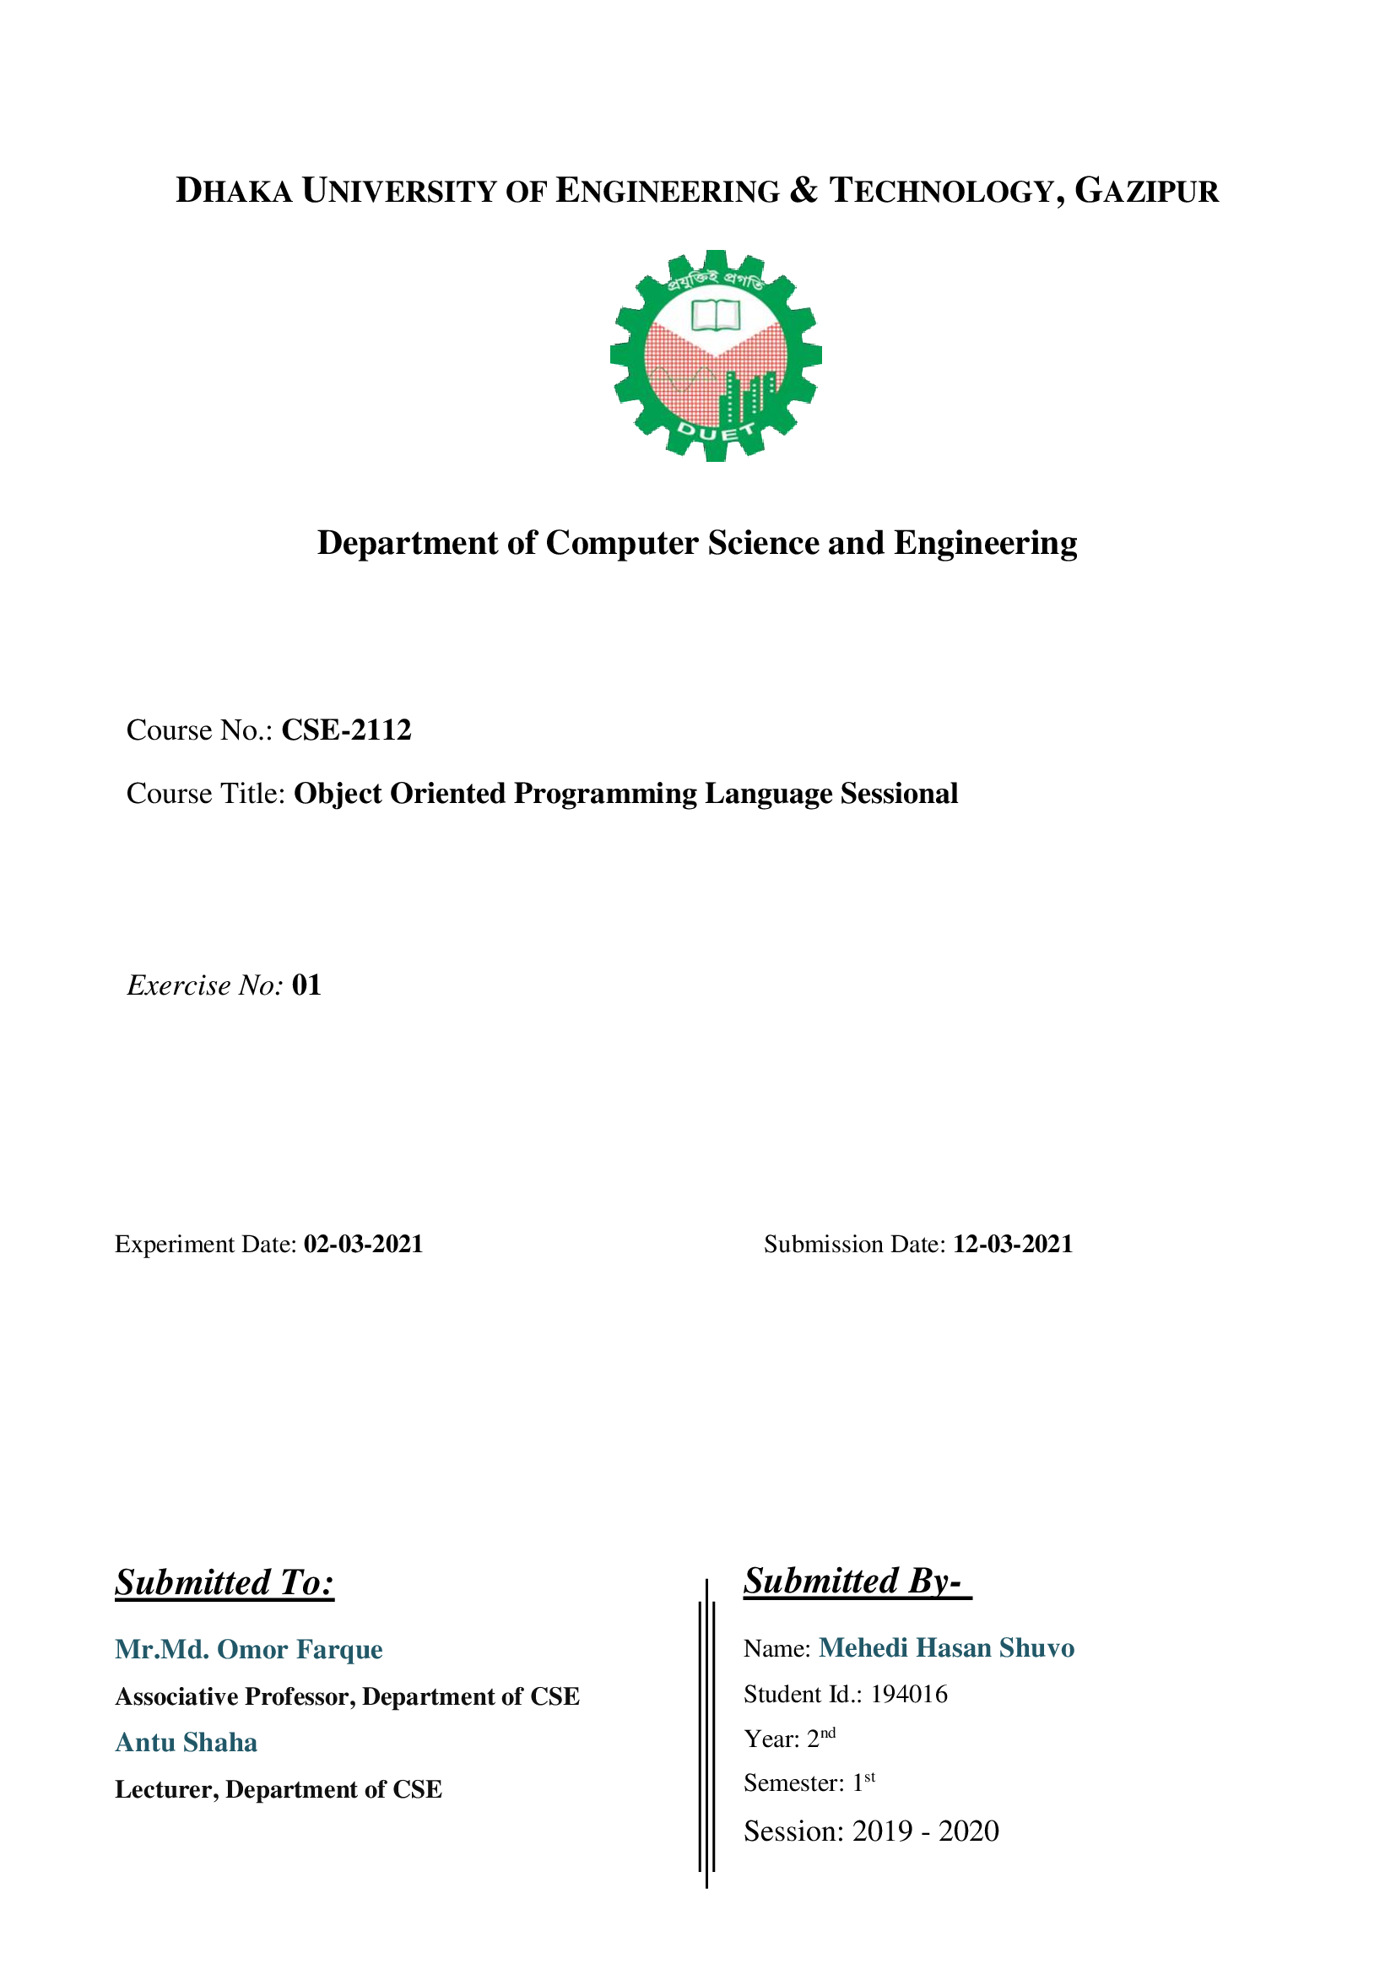

|  |
| --- |
| #include <iostream>  using namespace std;  int main()  {  int number[10];  int targetValue;  int n;  int firstIndex=0;  int lastIndex=0;  cout<<"Enter The Value Do you want add In Number list: ";  cin>>n;  for(int i=0; i<n; i++) cin>>number[i];  cout<<"Target Value: ";  cin>>targetValue;  for(int i=0; i<n; i++)  {  for(int j=0; j<n; j++)  {  if((number[i]+number[j])==targetValue)  {  firstIndex=i;  lastIndex=j;  break;  }  }  }  cout<<"\n\nOriginal Array: ";  for(int i=0; i<n; i++) cout<<number[i]<<" ";  cout<<"\nTarget Value: "<<targetValue<<endl;  if(firstIndex!=lastIndex)  cout<<"Indices of the two numbers whose sum equal to target value: "<<targetValue<<" "<<firstIndex<<" “<<lastIndex<<endl;  else cout<<"Indices of the two numbers whose not sum equal to target value: "<<targetValue<<endl;  return 0;  } |

**Problem 01:** Write a CPP program to get the indices of the two numbers of a given array of integers, such that the sum of the two numbers equal to a specific target.

**Solution:**

**Output:**

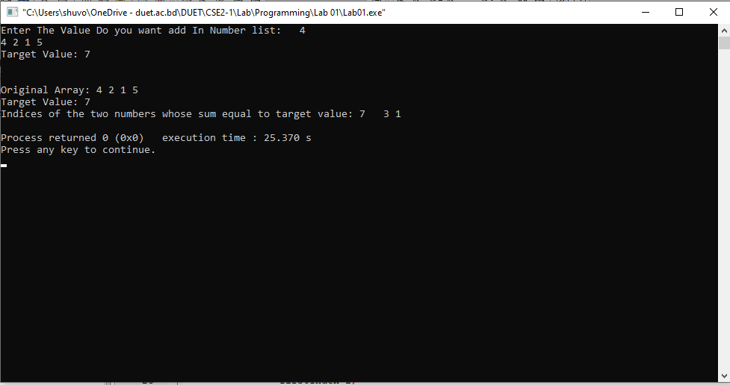

|  |
| --- |
| #include <iostream>  using namespace std;  int main(){  int number;  int orginalNumber=0;  int reverseNumber=0;  int modulas;  cin>>number;  orginalNumber=number;  while(number !=0){  modulas=number%10;  reverseNumber=reverseNumber*10+modulas;  number=number/10;  }  cout<<"Original integer: "<<orginalNumber<<endl;  cout<<"Reverse integer : "<<reverseNumber<<endl;  return 0;  } |

**Problem 02:** Write a CPP program to reverse digits of a given a 32-bit signed integer.

**Solution:**

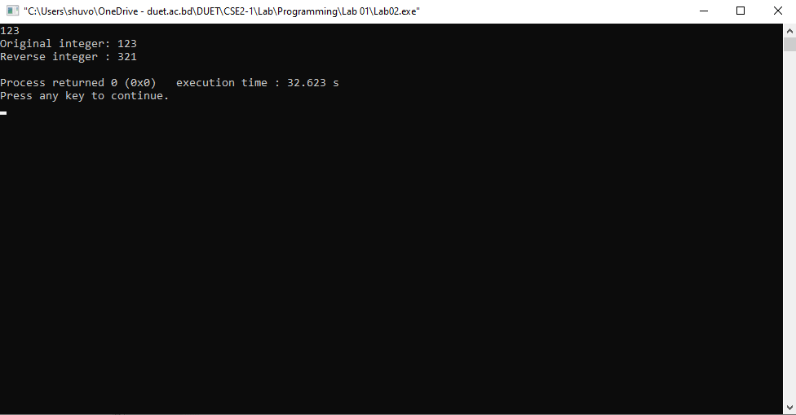**Output:**

|  |
| --- |
| #include<iostream>  using namespace std;  int main()  {  string inputText;  int inputTextLength;int vowel=0;  int consonent=0;  int value=0;  getline (cin, inputText);  inputTextLength=inputText.size();  for(int i=0; i<inputTextLength; i++)  {  value=inputText[i];  if(value==65 || value==69|| value==73|| value==79|| value==85|| value==97|| value==101|| value==105|| value==111|| value==117) vowel++;  else if((value>=66 && value<=90 && value !=69&& value !=73&& value !=79&& value !=85) || (value>=98 && value<=122 && value !=101&& value !=105&& value !=111&& value !=117)) consonent++;  }  cout<<"Number Of Vowels: "<<vowel<<endl;  cout<<"Number Of Consonant: "<<consonent<<endl;  return 0;  } |

**Problem 03:** Write a CPP Program to Count the Number of Vowels, Consonants in a string.

**Solution:**

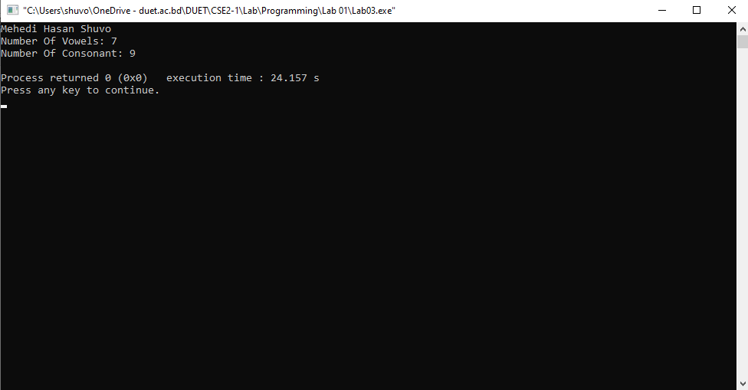**Output:**

***Thanks***